**London, UK – (April 25th 2015)** Today we are proud to announce the official relaunch of MansionGaming.

MansionGaming are a British Independent Developer founded in 2013 by two friends in order for them to create games that they themselves would enjoy.

Their first ever project was Undead Alliance, a planned post-apocalyptic, first person survival game with RPG elements, announced in 2013 which was put on hold in 2014.

With this official relaunch, we are announcing our first ever MansionGaming corporate logo and the launch of our first official site, mansiongaming.net.

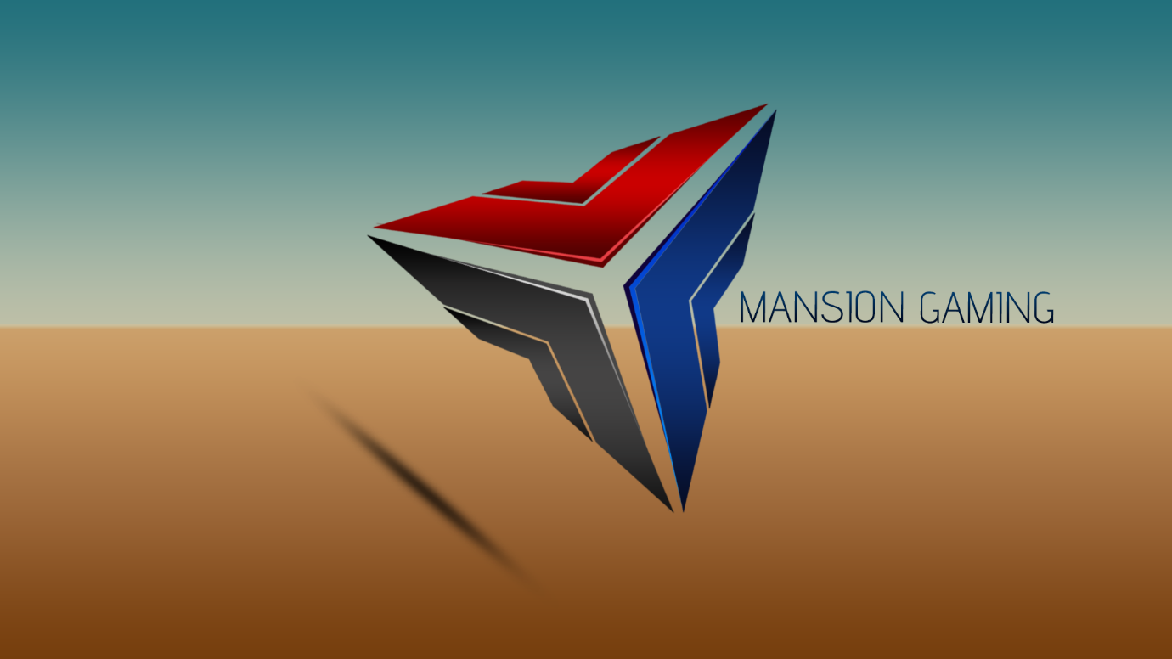

Undead Alliance had an official website and logo, however these were different from the MansionGaming corporate branding.

It is also with this relaunch we are happy to announce that we are proud to announce that we are working on a procedurally generated, mobile game due for release in September 2015. Both members of MansionGaming are working on this game.

Further information will come at a later date.

**Additional Resources:**

Website: <http://www.mansiongaming.net>

Facebook: <https://www.facebook.com/MansionGaming/>

Twitter: <https://twitter.com/MansionGaming?lang=en-gb>

Email: [contact@mansiongaming.net](mailto:contact@mansiongaming.net)

**Media Contacts:**

Joel Draper

[jepdraper@gmail.com](mailto:jepdraper@gmail.com)